**Implement CI/CD for Kubernetes with Jenkins and Spinnaker**

**Create Spring-Boot project with 5 Micro services**

* **API-gateway**
* **Car – service**
* **Location – Service**
* **Discovery – Service**
* **Reservation - Service**

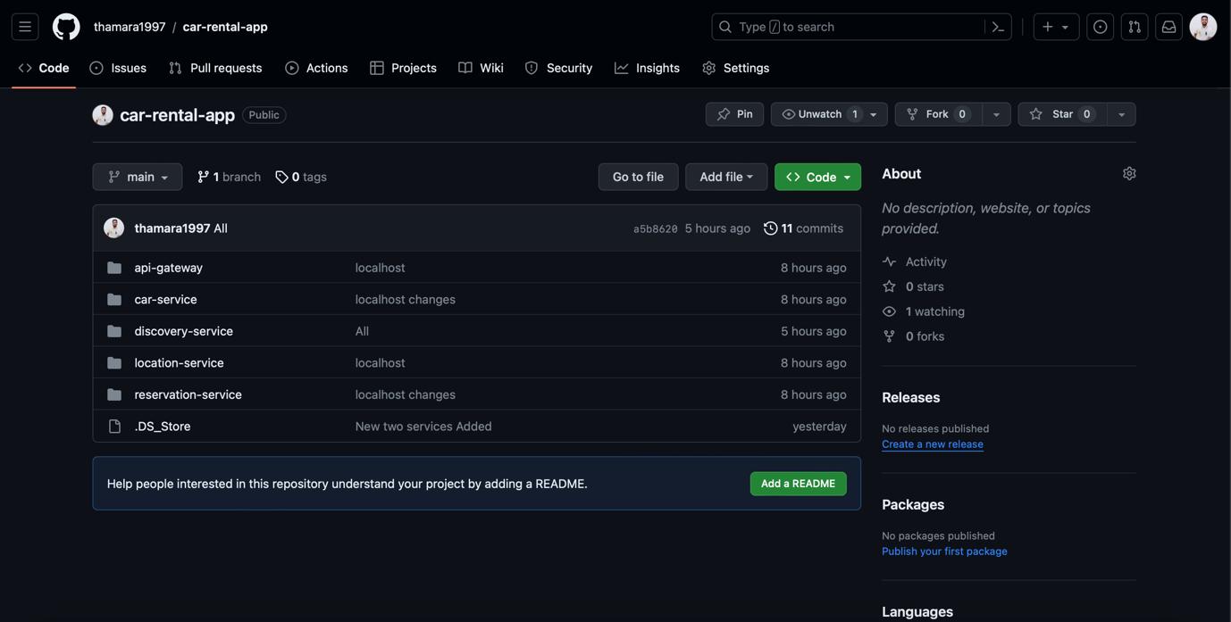**Push the code in to GitHub**

**Create Jenkins-Docker Instance (EC2)**

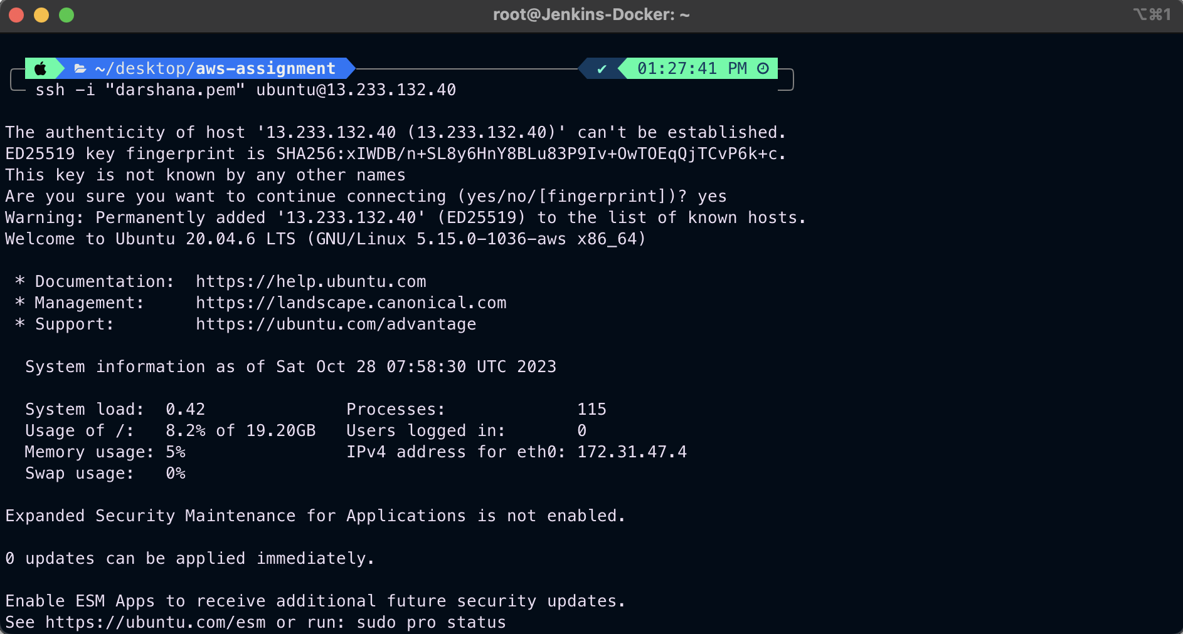

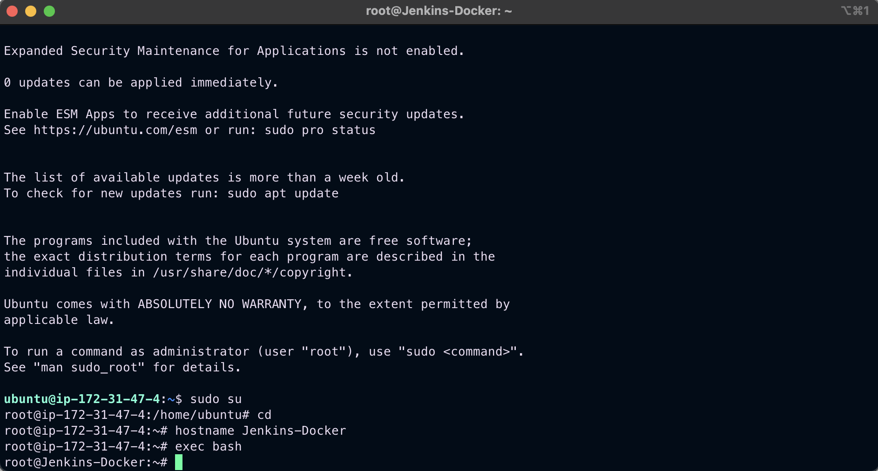

apt-get update (for get update from instance)

Install Jenkins(Using Jenkins.sh)

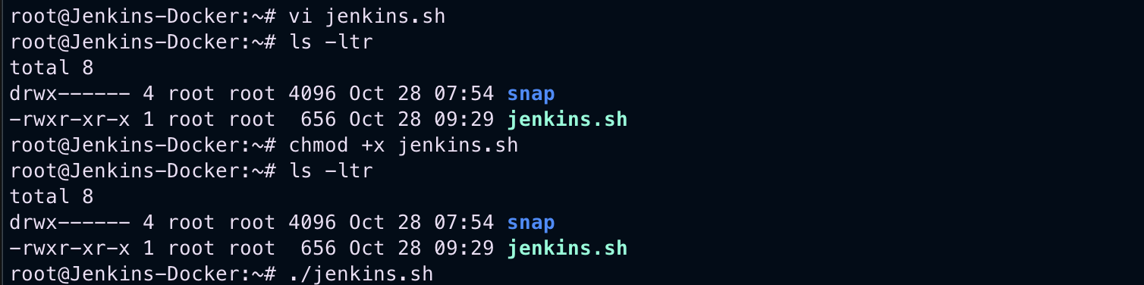

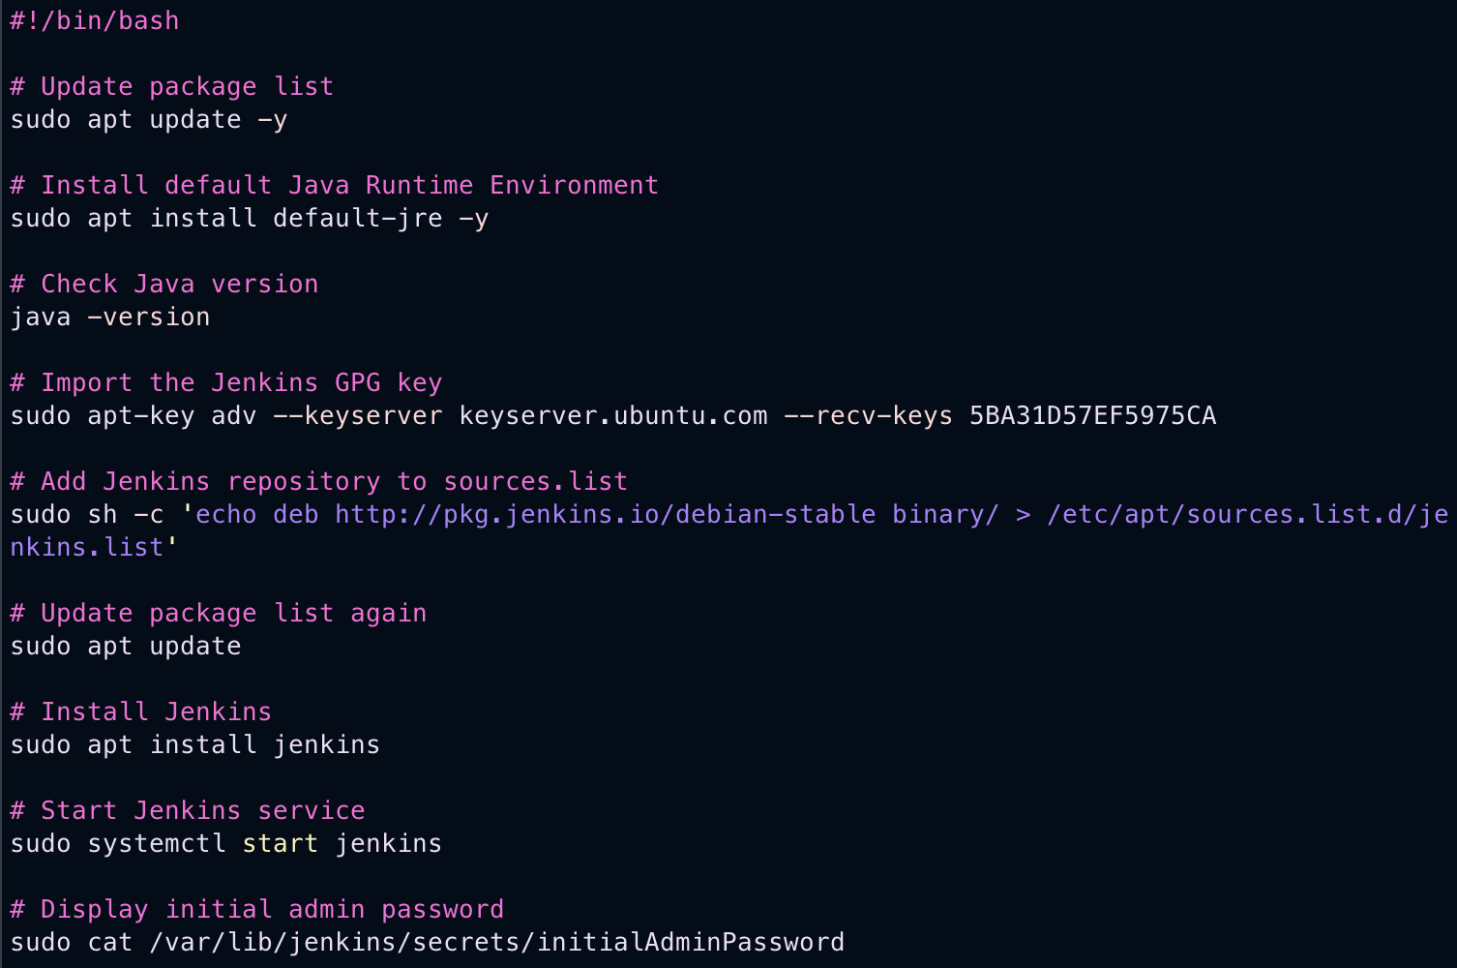

sudo systemctl start Jenkins

sudo systemctl status Jenkins

once we enter this it gives KEY to password for the first time then register for Jenkins account and go to dashboard

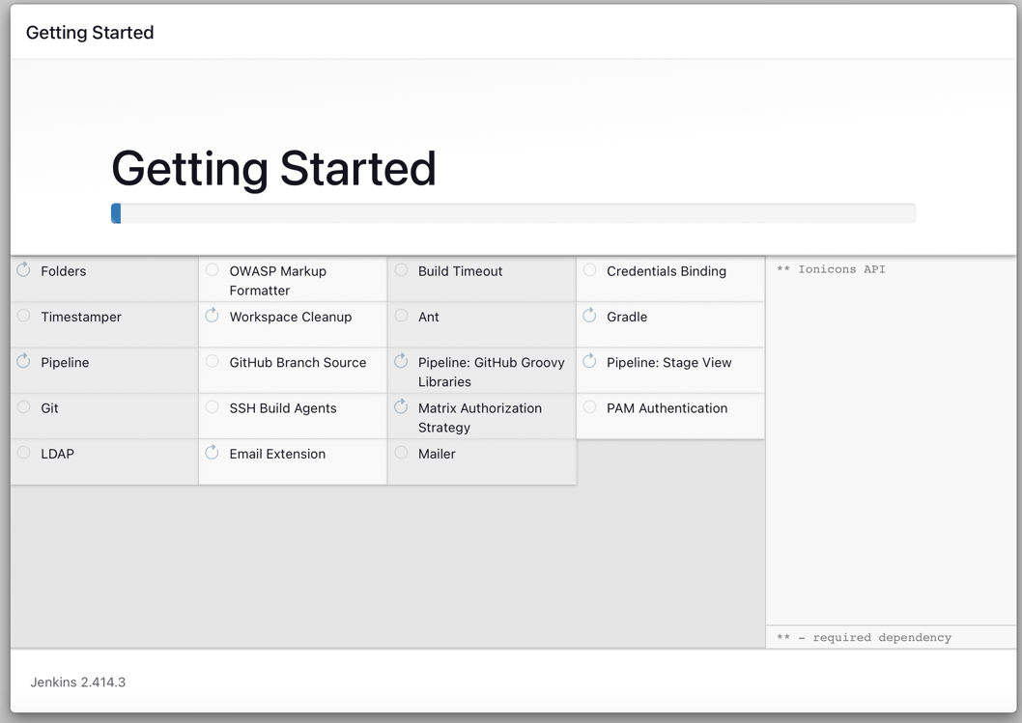

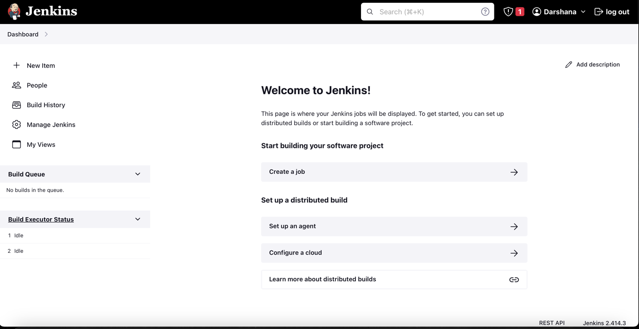

**Install Git**

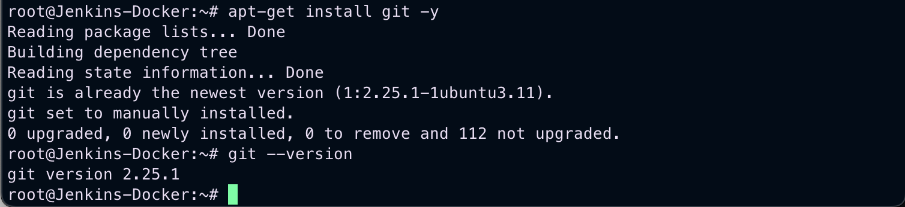

**Install Docker**

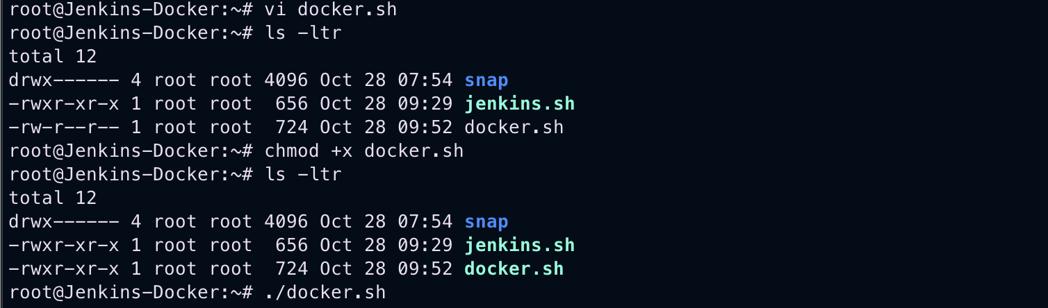

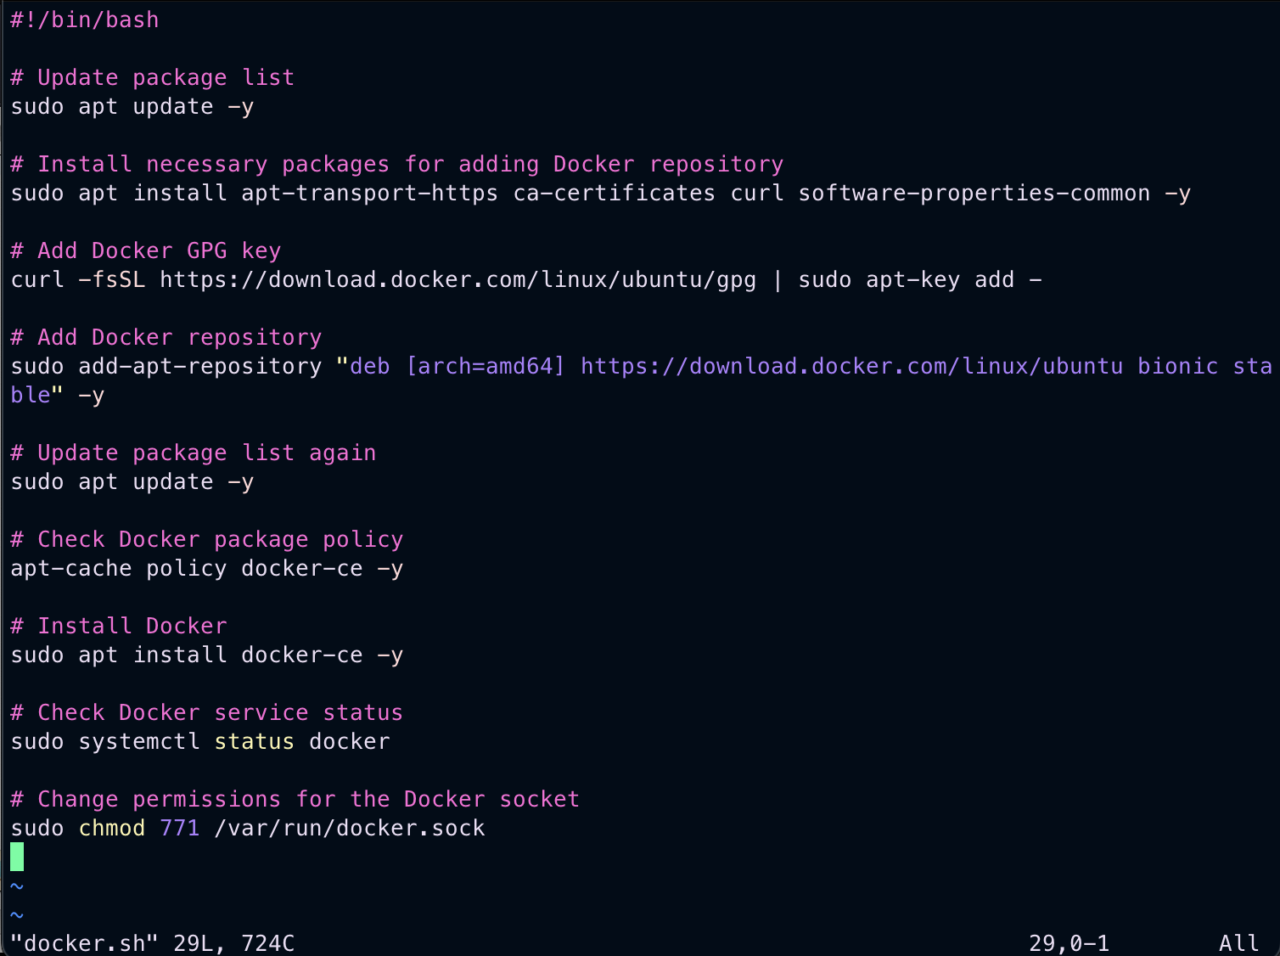

**Using these Commands**

wget <https://mirrors.estointernet.in/apache/maven/maven-3/3.6.3/binaries/apache-maven-3.6.3-bin.tar.gz>

tar -xvf apache-maven-3.6.3-bin.tar.gz

mv apache-maven-3.6.3 /opt/

vim ~/.bash_profile

M2_HOME='/opt/apache-maven-3.6.3'

PATH="$M2_HOME/bin:$PATH"

export PATH

mvn -version

**Installed Maven**

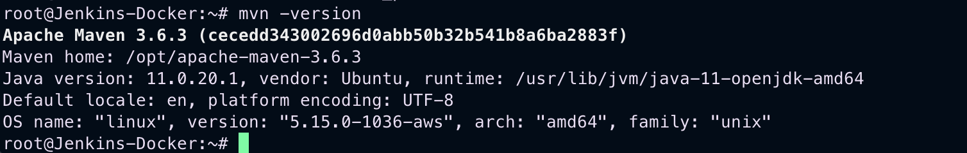

**In Jenkins Have to add this Maven**

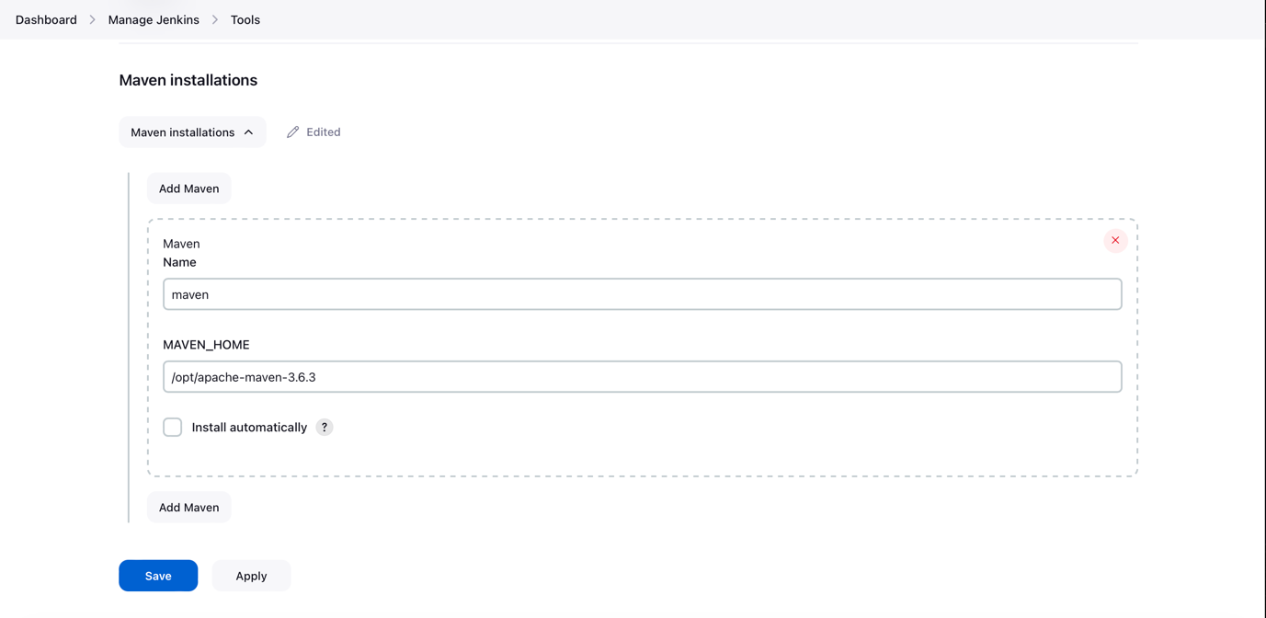

**Install Plugins**

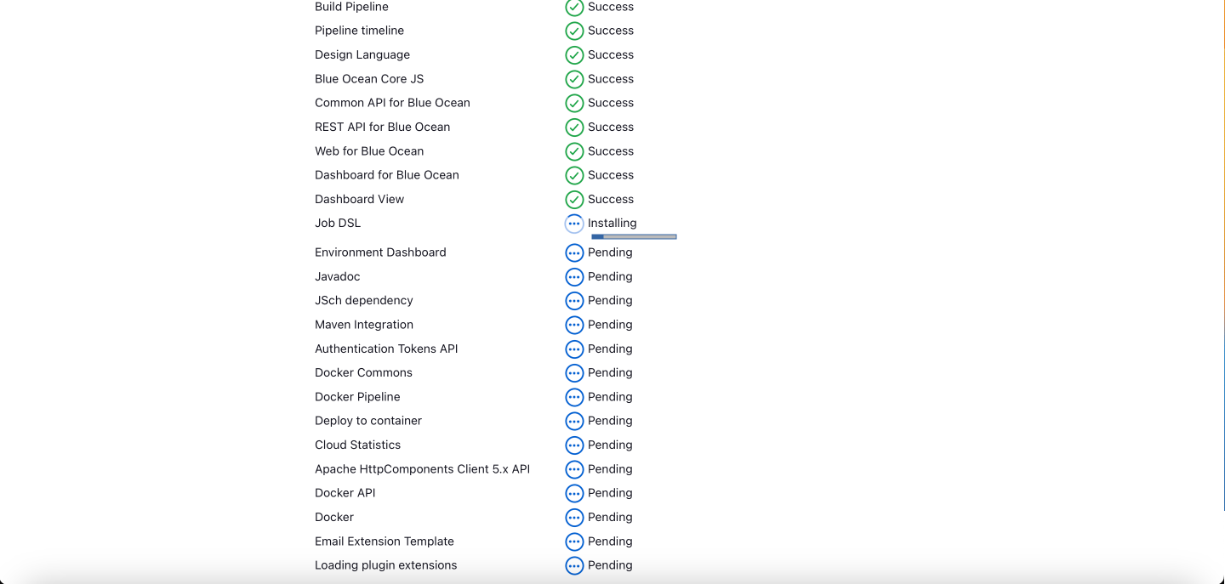

**Create Docker Account And login**

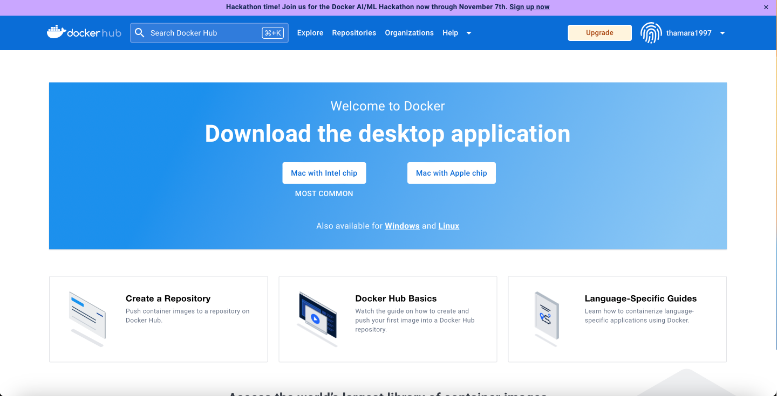

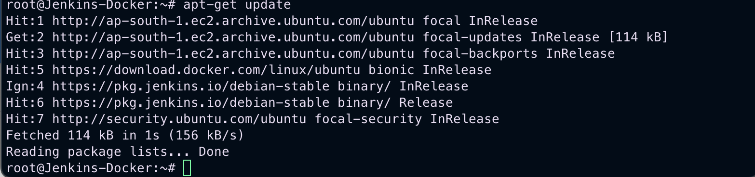

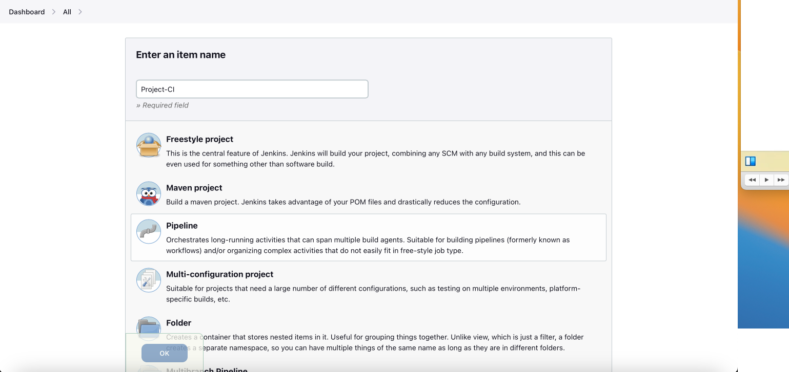**Create Pipe Line**

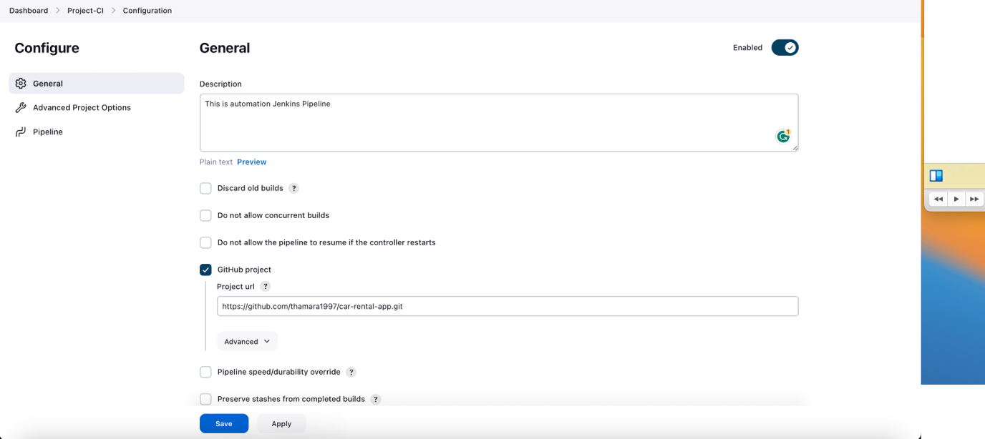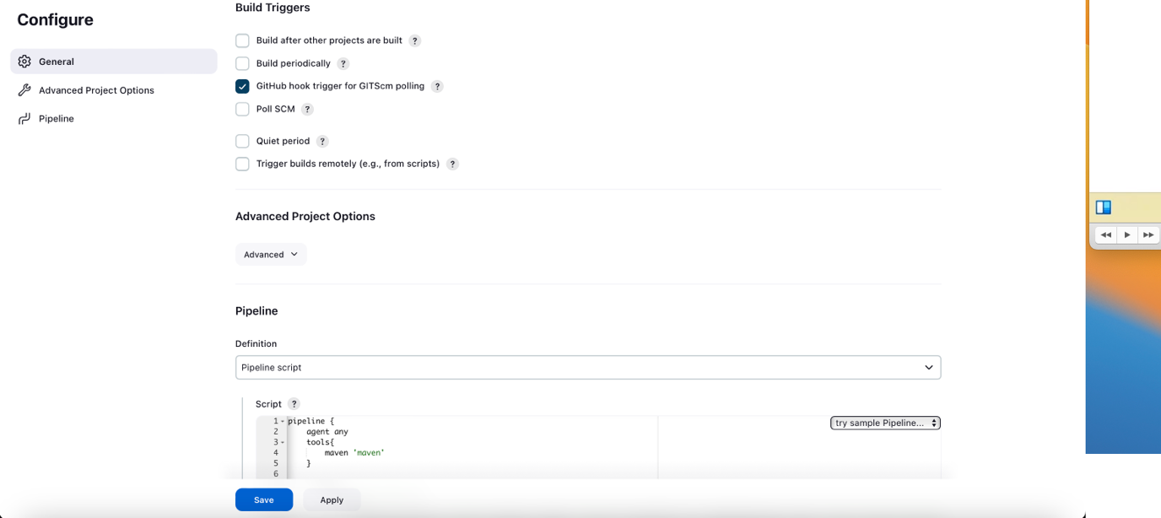

Pipeline Syntax can be generated by using this

**Creating MySQL Server in another Instance**

To Install as root user, type below command

sudo su

Then update the local package with below command.

sudo apt update

Install the mysql server package with below command.

sudo apt install mysql-server

**Check the MySQL server status**

sudo systemctl status mysql

**Start MySQL database server.**

sudo systemctl start mysql

**Login into MySQL DB**

mysql -u root -p

No password to enter.

**Create the data base with below query.**

CREATE DATABASE IF NOT EXISTS `car_rental_db`; show databases;

**Create tables in database.**

USE `car_rental_db`;

**Create Car Table**

*CREATE TABLE IF NOT EXISTS `t_cars` (*

*`id` int NOT NULL AUTO_INCREMENT,*

*`car_code` varchar(255) CHARACTER SET utf8mb4 COLLATE utf8mb4_unicode_ci DEFAULT NULL,*

*`make` varchar(255) CHARACTER SET utf8mb4 COLLATE utf8mb4_unicode_ci NOT NULL,*

*`model` varchar(255) CHARACTER SET utf8mb4 COLLATE utf8mb4_unicode_ci NOT NULL,*

*`year` int NOT NULL,*

*`license_plate` varchar(20) CHARACTER SET utf8mb4 COLLATE utf8mb4_unicode_ci NOT NULL,*

*`availability` tinyint(1) NOT NULL,*

*`image_url` varchar(255) CHARACTER SET utf8mb4 COLLATE utf8mb4_unicode_ci DEFAULT NULL,*

*`location_uuid` varchar(255) CHARACTER SET utf8mb4 COLLATE utf8mb4_unicode_ci DEFAULT NULL,*

*`per_hour_rate` decimal(10,2) NOT NULL, `per_day_rate` decimal(10,2) NOT NULL, `leasing_rate` decimal(10,2) NOT NULL, `car_description` varchar(255) DEFAULT NULL, `mileage` bigint DEFAULT NULL, `transmission` varchar(255) DEFAULT NULL, `seats` int DEFAULT NULL,*

*`luggage` int DEFAULT NULL,*

*`fuel` varchar(50) DEFAULT NULL,*

*PRIMARY KEY (`id`)*

*) ENGINE=InnoDB AUTO_INCREMENT=2 DEFAULT CHARSET=utf8mb4 COLLATE=utf8mb4_0900_ai_ci;*

**Enter Data into table (‘t_cars’)**

INSERT INTO `t_cars` (`id`, `car_code`, `make`, `model`, `year`, `license_plate`, `availability`, `image_url`, `location_uuid`, `per_hour_rate`, `per_day_rate`, `leasing_rate`, `car_description`, `mileage`, `transmission`, `seats`, `luggage`, `fuel`) VALUES

(1, '45f6f72c-6f6a-4b36-9d33-954ccb62be0a', 'Lexus', 'Lexus 2022', 2022, 'BGH 9072', 1, 'assets/img/lexus1.jpg', '71d45ae7-

92f5-4621-9d3d-1e407967a79f', 12.99, 111.12, 4243.98, 'A small river named Duden flows by their place and supplies it with the necessary regelialia.', 12120, 'Manul', 5, 5, 'Petrol');

**Create location table.**

CREATE TABLE IF NOT EXISTS `t_locations` (

`id` int NOT NULL AUTO_INCREMENT,

`location_name` varchar(255) CHARACTER SET utf8mb4 COLLATE utf8mb4_unicode_ci NOT NULL,

`location_address` varchar(255) CHARACTER SET utf8mb4 COLLATE utf8mb4_unicode_ci NOT NULL,

`location_uuid` varchar(36) NOT NULL,

PRIMARY KEY (`id`)

) ENGINE=InnoDB AUTO_INCREMENT=8 DEFAULT CHARSET=utf8mb4 COLLATE=utf8mb4_0900_ai_ci;

**Enter Data into Location table.**

INSERT INTO `t_locations` (`id`, `location_name`, `location_address`, `location_uuid`) VALUES

(1, 'Wellawaya', 'Wellwaya Road Wellwaya', '71d45ae7-92f5- 4621-9d3d-1e407967a79f'),

(2, 'Colombo', 'Colombo Road Colombo', '5fbf593f-cf44-4562- 825a-6b932b117587'),

(3, 'Kandy', 'Kandy Road Kandy', 'a62414fd-c56e-4de0-9409- f7b7f5a7c71d'),

(4, 'Jaffna', 'Jaffna Road Jaffna', '5e1a43cc-b67b-4e98- b0bb-6ae33535180e'),

(5, 'Gampaha', 'Gampaha Road Gampaha', '5056fb9b-bbbc-404d- 964b-a50bc26235f2'),

(6, 'Galle', 'Galle Road Galle', 'cde00356-1321-4bbc-b648- afcbd9f3dfcf'),

(7, 'Matara', 'Matara Road Matara', '34043148-d701-4f11- 9525-5fb965be2f2d');

**Create a reservation table.**

CREATE TABLE IF NOT EXISTS `t_reservations` (

`id` int NOT NULL AUTO_INCREMENT,

`reservation_number` varchar(255) CHARACTER SET utf8mb4 COLLATE utf8mb4_unicode_ci NOT NULL,

`start_date` date NOT NULL,

`end_date` date NOT NULL,

`reservation_status` varchar(255) CHARACTER SET utf8mb4 COLLATE utf8mb4_unicode_ci NOT NULL,

`reservation_car_code` varchar(255) CHARACTER SET utf8mb4 COLLATE utf8mb4_unicode_ci NOT NULL,

`car_quantity` bigint NOT NULL,

`total_cost` decimal(10,2) NOT NULL,

PRIMARY KEY (`id`)

) ENGINE=InnoDB AUTO_INCREMENT=3 DEFAULT CHARSET=utf8mb4 COLLATE=utf8mb4_0900_ai_ci;

**Insert data into the Reservation table.**

INSERT INTO `t_reservations` (`id`, `reservation_number`, `start_date`, `end_date`, `reservation_status`, `reservation_car_code`, `car_quantity`, `total_cost`) VALUES

(1, 'd2b42c10-6f31-4604-be5e-8cd146cb2411', '2023-09-13', '2023-09-21', '2', '45f6f72c-6f6a-4b36-9d33-954ccb62be0a', 2, 888.96),

(2, '1ca01598-c2bd-4885-a5ab-69c8dc3aab62', '2023-09-06', '2023-09-21', '0', '45f6f72c-6f6a-4b36-9d33-954ccb62be0a', 1, 1666.80);

**Change localhost to public.**

SELECT user, host FROM mysql.user;

UPDATE mysql.user SET Host = '%' WHERE User = 'root';

exit;

and make sure to restart the database.

sudo systemctl restart mysql

**Again, Login to the MySQL DB to change the root password.**

mysql -u root -p

(no need to type password just enter)

ALTER USER 'root'@'%' IDENTIFIED WITH mysql_native_password BY 'demoadmin';

exit;

and make sure to restart the database. Run the following command.

sudo systemctl restart mysql

**Change my SQL configuration’s exiting bind address.**

sudo nano /etc/mysql/mysql.conf.d/mysqld.cnf

and change the bind-address as follow,

bind-address --------> 0.0.0.0

and make sure to restart the database. Run the following command.

sudo systemctl restart mysql

**Create DockerFile on every microservices**

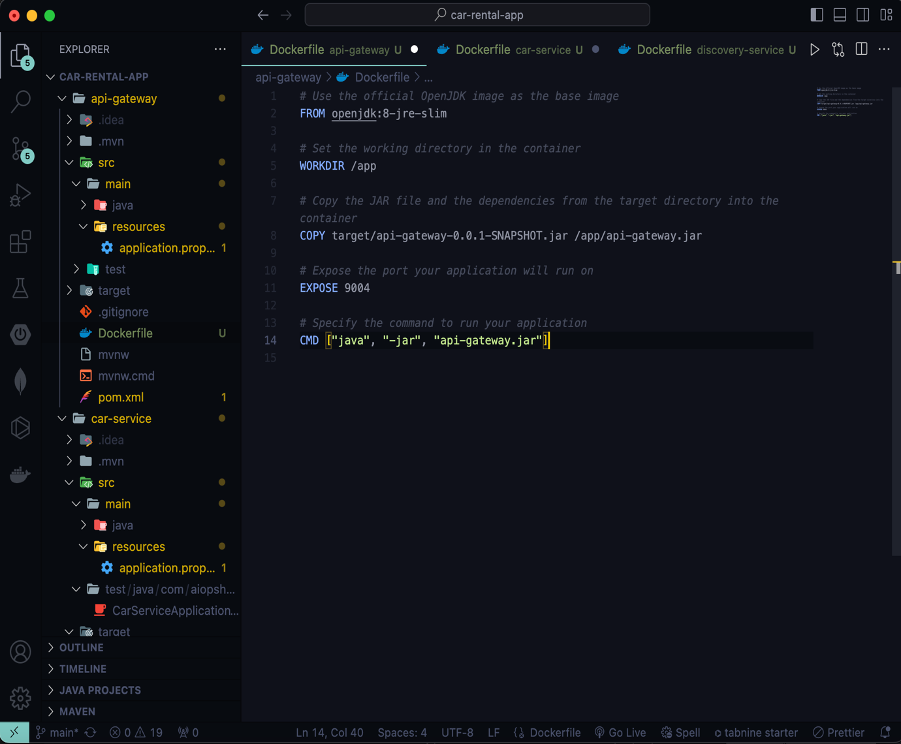

**Then in Jenkins Update the Shell Script to Dockerize the microservices in Docker**

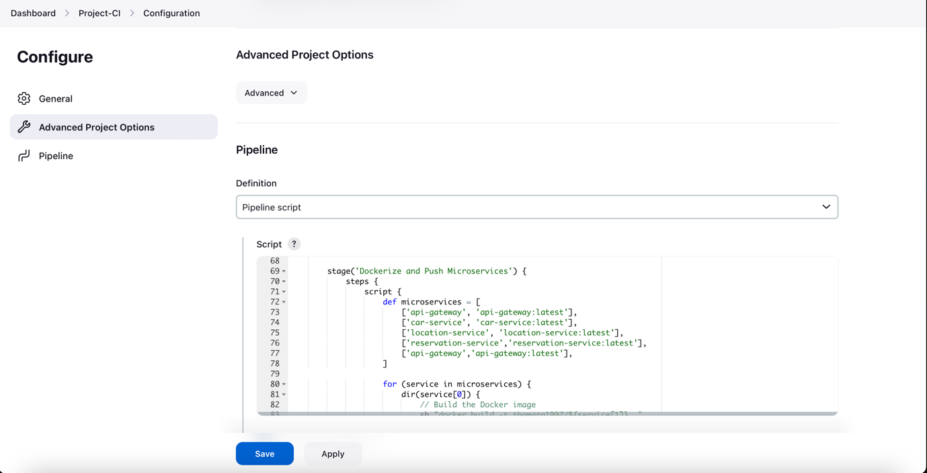

1. You should have to add credentials to Jenkins and configure
2. Then All the Microservices On DockerHub
3. Successfully Deployed

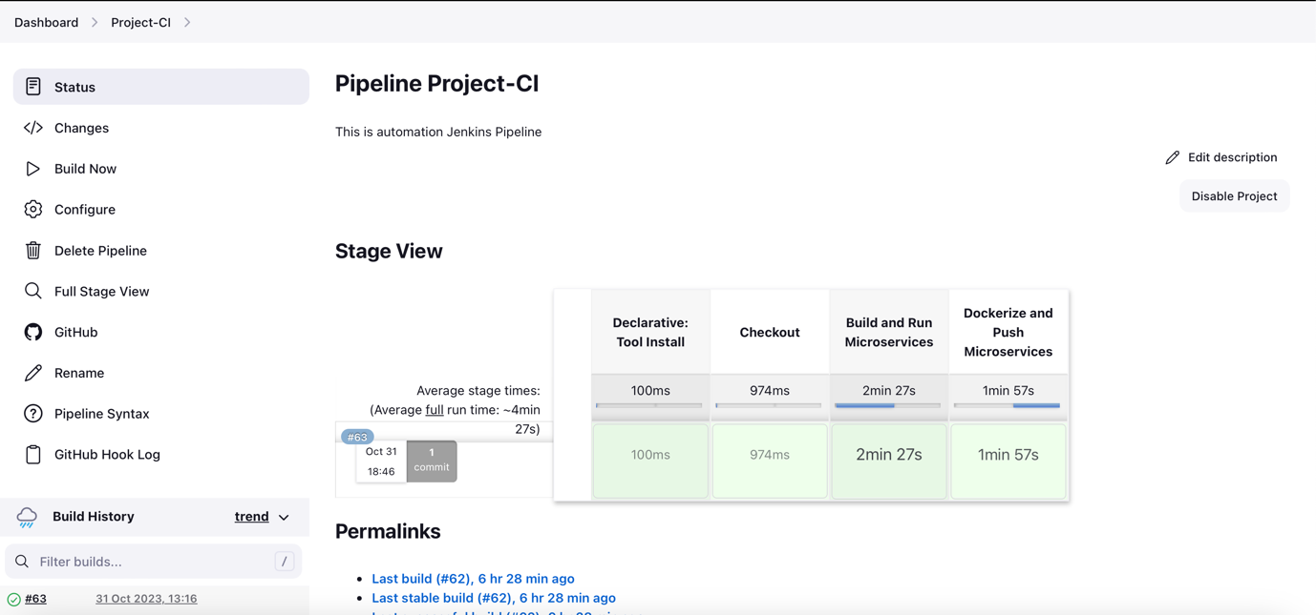

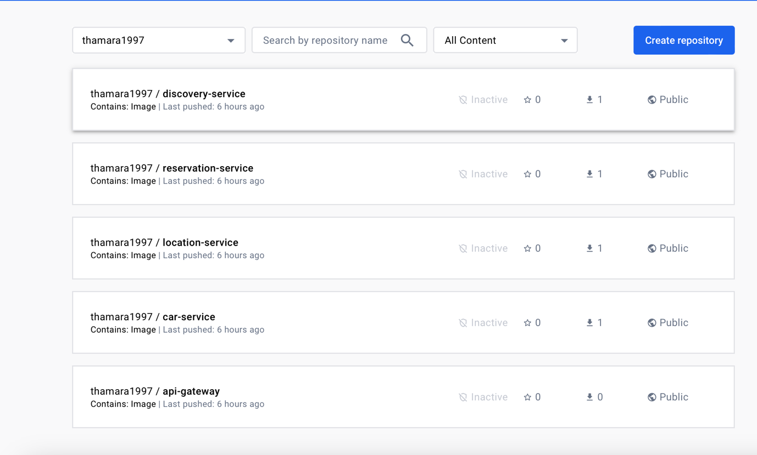

**Create Spinnerker EC2 Instance and Configured**

https://spinnaker.io/docs/setup/install/halyard/

https://spinnaker.io/docs/setup/install/deploy/

s3

------

hal config storage s3 edit --access-key-id $YOUR_SECRET_KEY_ID --secret-access-key

hal config storage edit --type s3

But Once I run this

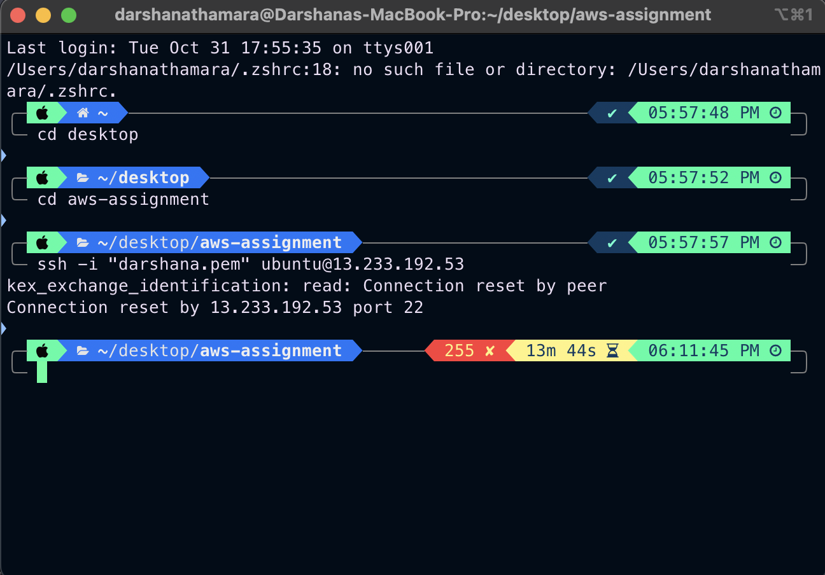

☹ ☹

AWS Provider

--------------

hal config provider aws edit --access-key-id $YOUR_SECRET_KEY_ID --secret-access-key

hal config provider aws account add $AWS_ACCOUNT_NAME --account-id ${ACCOUNT_ID} --assume-role role/spinnakerManaged

hal config provider aws account edit $AWS_ACCOUNT_NAME --regions us-east-1

hal config provider aws enable

**TO-DO**

* **Make Kubernates Cluster**
* **Add yml configuration to every Microservices**
* **Change IP address in all the microservices (Localhost to relevant IP)**
* **Make Spinnerker to trgier Jenkins once Git file changed**